Prediction of immunity levels using enhanced RNN deep learning algorithm

ABSTRACT:
The main objective of the study is to develop a totally a model of next-level to predict the immunity system against the COVID-19 pandemic, by using the capabilities of Artificial intelligence. The study introduces an hybrid approach combining the Recurrent Neural Networks (RNN) and Long Short-Term Memory (LSTM) models, which is enhanced by the Adaptive Chaotic Harmony Optimization (ACHIO) algorithm. The method involves in the feature extraction and selection of identify crucial characteristic for the prediction model. ACHIO is used for the feature selection and to tune epoch and neuron counts in the RNN and LSTM to enhance performance. The proposed model achieved some serious notable results including a 90.42% precision, 80% precision, 90.86% specificity, 89.53% sensitivity, 86.03% F1 score, 17.20% false discovery rate(FDR), 90.86% negative predictive value(NPV), 10.47% false negative rate(FNR), and 9.14% false positive rate(FPR). Comparative analysis with other deep learning models such as DNN, RNN, CNN, RBM, LSTM and combined RNN+LSTM indicates that the proposed model outperforms existing standards like totally. The integration of ACHIO with hybrid RNN and LSTM model for the prediction of COVID-19 herd immunity levels is the unique aspect of this study. This makes everything exciting and shows enhanced accuracy and efficiency in forecasting like surpassing existing deep learning models in performance matrix.
Keywords: Immunology, Immunity levels, recurrent neural network, LSTM, GRU, ML, Data driven predictions.
1.Introduction:
The COVID-19 pandemic, which started in Wuhan, China in late 2019, has spread throughout the world and deemed an emergency by the World Health Organisation in March 2020.By August 2020 there were more than 24 million cases has been reported, placing a burden on healthcare systems in the US, France, Italy, Spain and India. Like this scenario demonstrates the urgent need of the technology solutions, especially in deep learning and artificial intelligence to control and lessen the effects of the infection. To handle this difficulty, the study applies an upgraded RNN deep learning algorithm to predict immunity levels in people exposed to or recovering from COVID-19. The assessment of immunity levels is essential for efficient viral warfare, impacting therapeutic regimens, vaccine research and public health regulations. The research combines ensemble approaches with time-delay neural networks (TDNN) to address the erratic character of real-world data. The main goal is to increase prediction accuracy by averaging the results and utilizing standard deviation as dependability metric. The traditional techniques like diagnostic imaging etc. are handful but not might be able to cope up with the rapid evolution, since they involve a lot of feature extraction and training. The main goal of using RNN is for effective and precisely forecast immunity levels, which is essential for fighting COVID-19.This AI approach considerably contribute to international efforts in comprehending and containing the spread of COVID-19 by demonstrating the study's significance and applicability in tackling the present health issues.
2. Literature review:
Recurrent Neural Networks (RNN) and Long Short-Term Memory (LSTM) are used to perform the prediction of immunity levels in people who are affected by COVID-19.These two algorithms performed well with the given datasets in classifying the data in different types with efficiency. There are various research's which assisted for the use of RNN and LSTM for the prediction of the immunity levels in people as stated below:
1. Zain ZM, Alturki NM et al [21] described that accurately forecasting the trend of cases globally, the spread of the pandemic can be controlled by using hybrid CNN-LSTM model.
2. Cho K, Kim Y et al [22] proposed a new approach for streamflow prediction that combines WRF-hydro and LSTM network which helps in accuracy, reduce large datasets, avoid overfitting.
3.W Xiangxue, X Lunhui, C Kaixun et al [19] proposed framework for traffic flow by using forecasting module like LSTM-RNN, they outperforms other deep learning algorithms in terms of accuracy and stability.
4.AK Dubey, A Kumar, R Agrawal et al [21] investigated an efficient framework for classifying and preprocessing big data using ant colony optimization(ACO) and particle swarm optimization(PSO) algorithms.
5. H Sadr, MM Pedram, M Teshnehlab et al [20] described an approach for more accurate and efficient sentiment analysis. By using proposed solution multi-view deep networks that combines different neural networks like CNN and RNN.

Based on the outcomes of the above four methodologies prediction of the immunity levels is done accurately by using RNN and LSTM. But, as these four were centred on the methodologies of framework for forecasting and prediction, there are few other work which are classified upon the basis immunity levels, herd immunity, herd effect, strategies for lowering the morality rate, strategies for maximum vaccination and there are some machine learning algorithms for prediction of COVID-19 outbreak. These researches’s below tells us more about the COVID-19 pandemic and controlling of it and few terms to define the immunity levels in the people. Considering the literature's based upon the classifications are as follows:
1. TJ John, R Samuel et al [2000] proposed precise term on herd immunity and herd effect, they both are measured differently and applied to different scenarios. Understanding these is crucial for designing effective vaccination programs.
2. Fine PE et al [1993] described the concept of herd immunity and its history, theory and practices showed the importance of it in protecting population from infections.
3. MM Mijwil et al [21]study applies machine learning to classify chest x-ray images for diagnosing COVID-19, viral pneumonia and healthy case. Random forest, logistic regression, naive bayes and support vector machine techniques are used.
4.Ragonnet R, Briffoteaux G, Williams BM et al [20] study uses a mathematical approach or model to compare different strategies for minimizing the mortality rate due to COVID-19 by reducing social contact between specific age groups.
5. Al-Betar MA, Alyasseri ZA, Awadallah MA et al [21] introduces a new optimization algorithm called CHIO, inspired by the concept of herd immunity in response to the COVID-19 pandemic it is strong performance across various problems.

3.Methodology and Datasets

The data across the countries provided on COVID-19 plays a vital role in the study. Thus RNN and LSTM based model predicts the immunity levels of the people based upon this data. This techniques used are accurate and efficient for placing a strong impact on the data management. These models are also used for the balancing of the data, hence this method are very much helpful in the classification of the imbalanced data set. A solid model construction is essential and training the model is crucial.
Recurrent Neural Networks (RNNs) are a class of artificial neural networks specially designed to capture sequential dependencies within data. Unlike traditional feedforward neural networks, RNNs have loops that allow information to persist. This architecture enables RNNs to effectively process sequences of data, making them particularly suited for tasks such as time series prediction, speech recognition, natural language processing, and more. The key idea behind RNNs is the ability to maintain a hidden state that evolves over time as new input is processed, allowing the network to incorporate context from previous steps into its predictions or classifications. Flow chart shown in fig-3.1

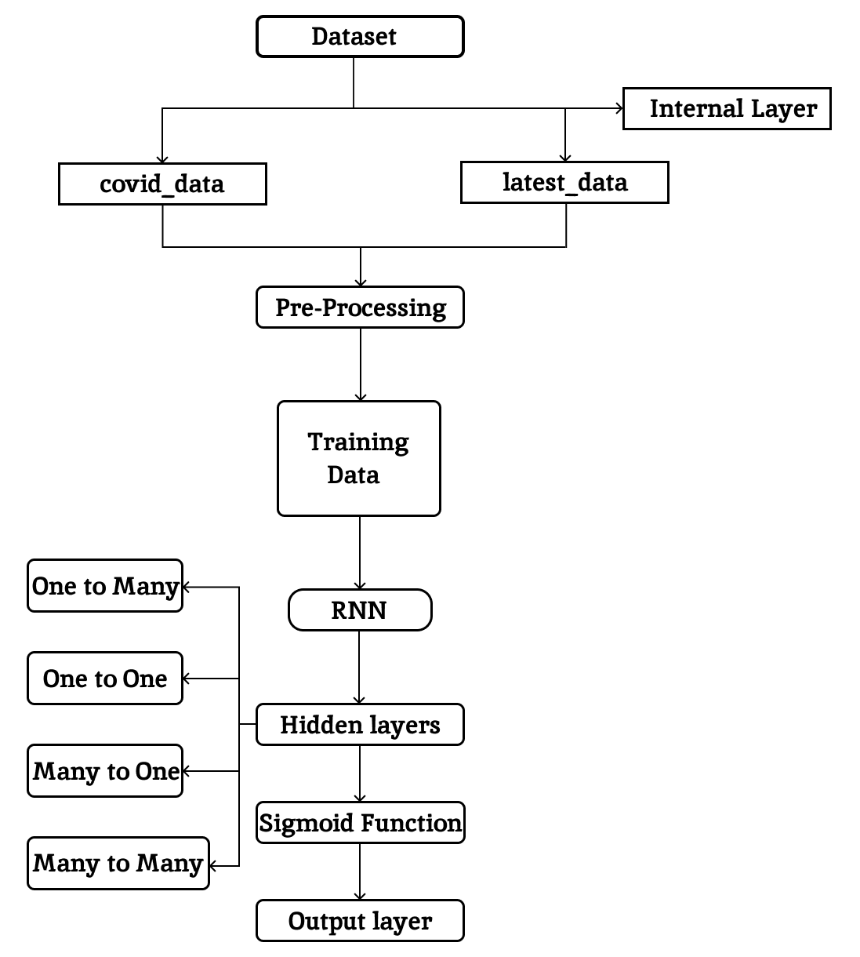

Fig-3.1-flowchart

Execution of the dataset:
Reads COVID-19 data for India from a CSV file into a pandas Data Frame [df].
NAME | SUB CSV DATA
Covid_data | India_covid_data.csv
Latest_data | India_lastest_case.csv
Table-1-covid dataset and latest data
The datasets "India_covid_data.csv" and "India_lastest_case.csv" as shown in [Table-1] together provide a comprehensive overview of the COVID-19 pandemic in India. "India_covid_data.csv" offers extensive historical data on confirmed cases, recoveries, deaths, and testing rates across various regions and time frames, essential for understanding the pandemic's progression and impact over time. In contrast, "India_lastest_case.csv" delivers up-to-date information on the latest COVID-19 cases, recoveries, and fatalities, vital for immediate public health response and policy planning. Combined, these datasets are invaluable for both retrospective analysis and current management of the COVID-19 situation in India.
S.no | iso_code | continent | date | Total cases | New cases | Deaths | New deaths | F-smoke | M_ smoke | Life expectancy | development
0 | IND | ASIA | 3-1-20 | 3 | 1 | NA | NA | 1.9 | 20.6 | 70% | 1%
1 | IND | ASIA | 3-2-20 | 5 | 2 | Na | Na | 1.9 | 20.6 | 70% | 1%
2 | IND | ASIA | 3-3-20 | 5 | 1 | NA | NA | 1.9 | 20.6 | 70% | 1%
3 | IND | ASIA | 3-4-20 | 28 | 23 | NA | NA | 1.9 | 20.6 | 70% | 1%
- | -
675 | IND | ASIA | 1-5-22 | 35109286 | 90928 | 325 | 288 | 1.9 | 20.6 | 70% | 1%
676 | IND | ASIA | 1-6-22 | 35226386 | 117100 | 302 | 299 | 1.9 | 20.6 | 70% | 1%
677 | IND | ASIA | 1-7-22 | 35368372 | 141986 | 285 | 282 | 1.9 | 20.6 | 70% | 1%
678 | IND | ASIA | 1-8-22 | 35528004 | 159632 | 327 | 288 | 1.9 | 20.6 | 70% | 1%
679 | IND | ASIA | 1-9-22 | 35707727 | 179723 | 146 | 291 | 1.9 | 20.6 | 70% | 1%
_{Table-2 INDIAN covid-19 CASES}
The [Table-2] shows the progression of COVID-19 in India from its initial cases in early March 2020 to capturing significant infections by September 2022. this include total and new cases, reported deaths, smoking rates among females (1.9%) and males (20.6%), life expectancy (70%), and a development indicator (1%). The initial data is for very few cases, and the number explodes to 35 million cases over two years showing the pandemic’s massive stress on the country’s health system and the social challenges. The smoking rate, life expectancy and development provides a view of the country’s health landscape during the pandemic.
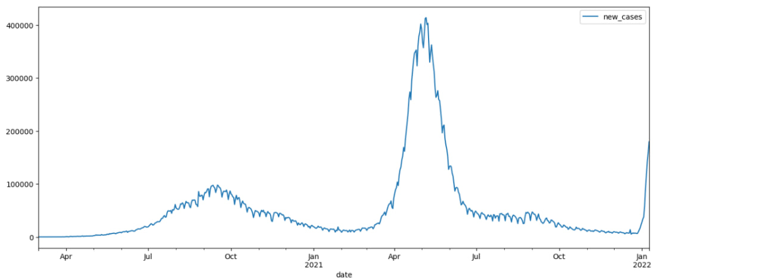
Fig-3.2 Increase of cases
In the code a series of data manipulation and visualization tasks on COVID-19 dataset for India is being performed using pandas library. By uploading a CSV file which consists of latest COVID-19 case data into DataFrame named 'df4' , with the 'data' column set as index.
The index is converted into a Data time format with the day-month-year style.Now, you link
'df4' with another DataFrame 'df', which reasonably contains earlier COVID-19 case data. This connection is done along the rows, results in a new DataFrame "Latest_cases" that holds a comprehensive dataset combing both 'df' and 'df4'.
DATES:
2020-03-01 | 1
2020-03-02 | 2
2020-03-03 | 1
2020-03-04 | 28
- | -
2022-05-04 | 3275
2022-05-05 | 3545
2022-05-06 | 3805
2022-05-07 | 3451
2022-05-08 | 3207
Table-3 No.of deaths in those dates
[Table-3]Now, the data from DataFrame'df2' is plotted using a specific size and grey color, which suggests that 'df2' contains COVID-19 case data up until Feb 8, 2022. Following this, the forecast of COVID-19 cases from another DataFrame 'forecast df' on the same plot, using red to distinguish the predicted data is overlaid. This forecast data ranges from Jan 11, 2022 to Feb 19, 2022. The visual representation of juxtaposes actual historical data against forecasted data, aiding in the analysis of the COVID-19 trend over time in India is the final output.

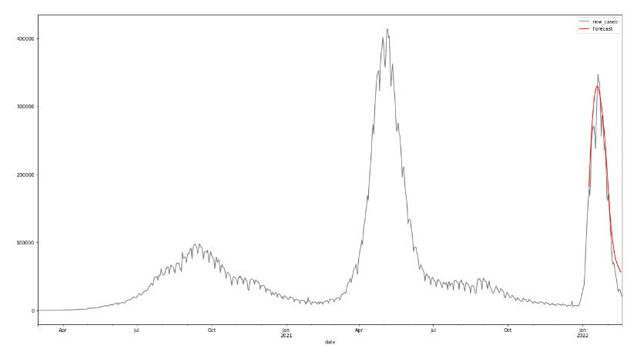
Fig-3.3 Final output layer

Best COVID-19 Forecasting in US, UK and Chile
The code focuses on analyzing and visualizing COVID-19 data by using python, pandas and Matplotlib. The main dataset used is uploaded from a CSV file . Specific data inconsistencies for Chile, United states and United kingdom. It calculates and plots the 7 day[Fig-3.4] moving avg of new cases and new deaths globally. The new cases and new deaths are visualized over time on a global scale.
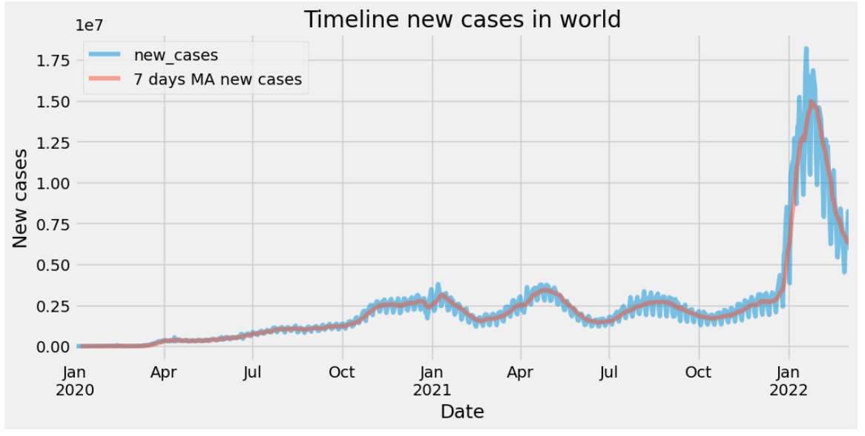
Fig-3.4 new cases in world
The [fig-3.4] graph shows COVID-19 cases globally from 2020 to 2022. A peak in January 2021 dipped steadily, with a minor August bump, before a consistent decline. The 7-day moving average smooths daily fluctuations, showing a similar downward trend.
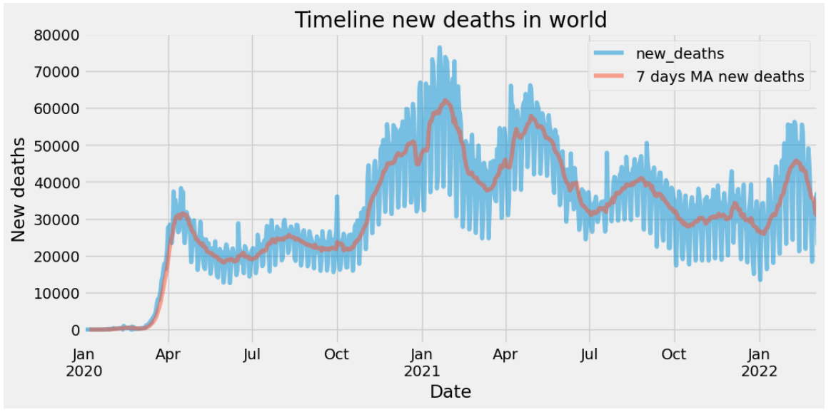
Fig-3.5 deaths in world
[Fig-3.5] shows the global rise in new deaths from January 2020 to January 2022. Interestingly, there was a sharp peak in January 2021, but as time went on, the numbers gradually declined, settling at approximately 10,000 new deaths per day towards the end of this timeline. However, it's important to note that the reported figures may not accurately reflect the full impact of COVID-19, as many deaths go untested therefore it include those deaths also.

4.Results and discussion:
"Prediction of Immunity Levels Using Enhanced RNN Deep Learning Algorithm," the code that is included provides an analysis which focuses on the use of LST, an RNN version, for COVID-19 case forecasting, which is an essential component of immunity level comprehension. The algorithm first uses an LST model that makes use of a series of 50 days worth of data to anticipate future COVID-19 instances in India. The method plays essential part for identifying patterns and trends in the illness, In order to help healthcare readiness and response. MinMaxScaler is crucial for neural network performance and it is the best possible input data scaling is ensured by it..Scales the data using MinMaxScaler. TensorFlow library is used to create an LSTM neural network for time series forecasting. It sets up, like, a time series generator to generate batches for training the LSTM model, which is super important and stuff. Compiling the model using the Adam optimizer and Mean Squared Error (MSE) loss function. LSTM, Total params, trainable data, non-trainable data are observed in [Table-4]

MODEL: “sequential”
Layer (type) | Output Shape | Param #
LSTM | None, 50,10 | 480
Dropout | None, 50,10 | 0
Lstm_1 | None, 50,10 | 2480
Dropout_1 | None, 50,20 | 0
Lstm_2 | None, 10 | 1240
Dropout_2 | None, 10 | 0
dense | None, 1 | 11
Table-4 LSTM
Total param: 4211(16.45 kb)
Trainable params: 4211(16.45 kb)
Non-trainable param: 0(0.00 byte)

[Table-4] The neural network architecture consists of three LSTM layers and Dropout layers for regularization. It gradually compresses sequential data through the layers and outputs a single value per sequence. This setup, with 4,211 parameters, is designed for tasks that involve understanding temporal patterns, like time series prediction or sequence classification. Dropout is used to prevent overfitting.
Additionally, the algorithm uses a 7-day moving average to smooth out daily variances and performs a worldwide analysis of COVID-19, focusing on new cases and fatalities. The worldwide view is essential for monitoring the virus's progress and assessing how well control efforts are working. The examination of vaccination rates and the correction of data abnormalities are part of the comprehensive investigation focussed on the US, Chile and the UK Given the vaccination data, this analysis, which is country-specific, is very pertinent to your work since it sheds light on the population's potential degree of immunity.
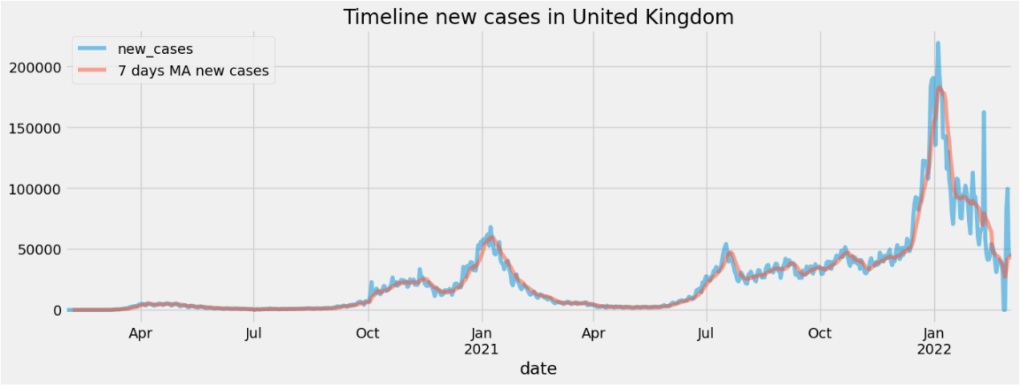
Fig-4.1 new cases in UK
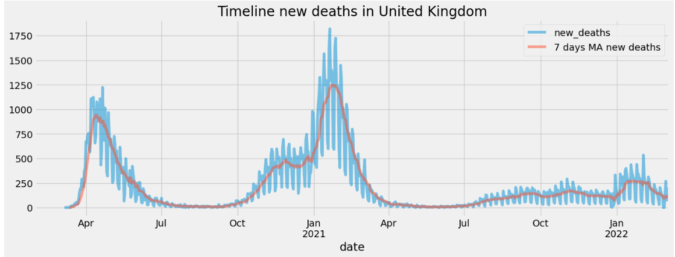
Fig-4.2 deaths in UK
The [fig-4.1] shows the new time line cases 7 days in UK. The graph shows a clear downfall trend, with the number of new cases peaking in April 2021 and then drops steadily. There is a slight increase in new cases in October and November 2021.Where as in [fig-4.2] the timeline of new deaths in the United Kingdom. It appears to cover data up until early 2022, as we can observe orange and blue line graph. We can see so much difference in fig-4.1 and fig-4.2 new cases and death cases.

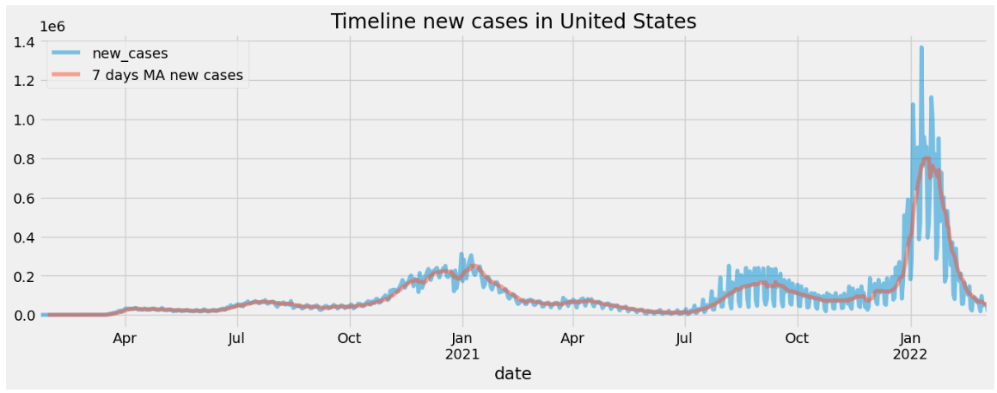
Fig-4.3 new cases in US
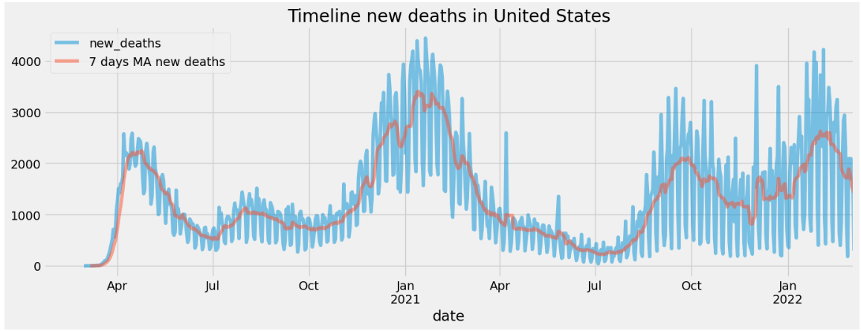
Fig-4.4 deaths in US
From [fig-4.3] we can observe that the new covid-19 cases in US in 7 days time period. There is an so much increaseing in new cases in JAN-2022. And there is a slight raise in JAN-2021. Where as in [fig-4.4] There as so many death cases as conpared to new cases in US. There is so much diffrence new cases and death cases there is huge increase in APR-2020 to JAN-2021.

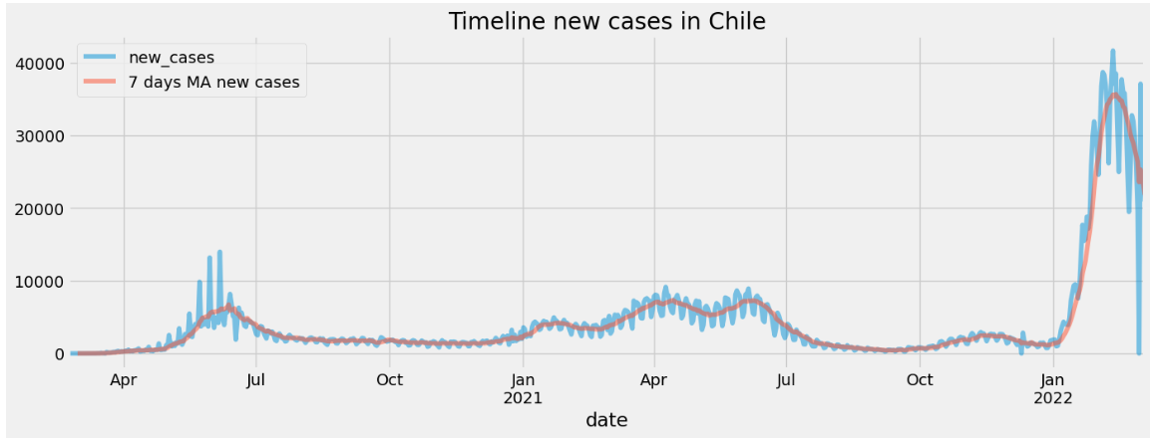
Fig-4.5 new cases in chile
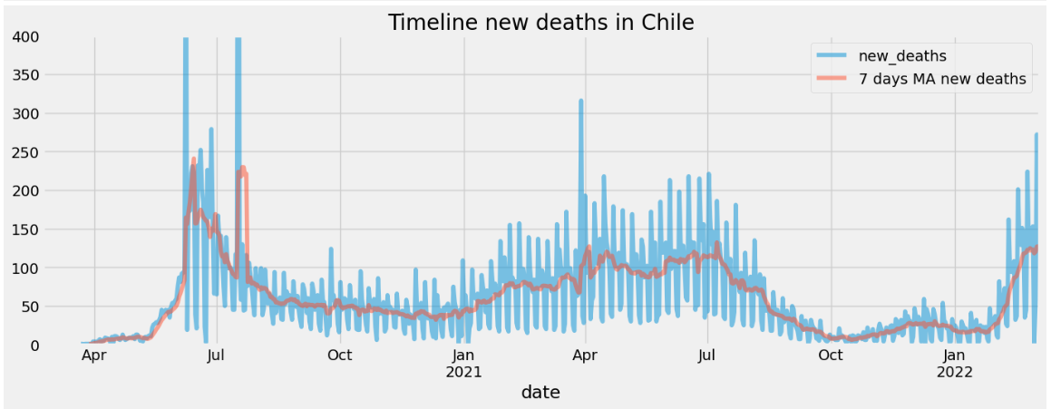
Fig-4.6 deaths in chile
From [fig-4.5] we can observe covid-19 new cases in period of 7 days there is a huge range in rise in JAN-2022. From APR-2020 to APR-2021 there is no such raise it looks some constant raise. Where in [fig-4.6] there are high rise in APR-2020 to JUL-2020. According to my observation Chile country has done to few deaths as compared to US and UK.
The study establishes the foundation even if it cannot predict immunity levels with precision. Estimation of herd immunity within populations may benefit from the combination of vaccination data and case predictions made by the LST model. The study opens the door to understanding how immunity changes over time in response to vaccination campaigns and the spread of the pandemic! Although they have a great influence on infection rates and immunity levels, factors that include viral variations, policy changes, and behavioural adjustments.
To sum up, the research offers a comprehensive comprehension of COVID-19 changes and their consequences for population immunity, which is crucial for informing public health strategies and predicting immunity levels.

4. Conclusions
In summary, the study "Prediction of Immunity Levels Using Enhanced RNN Deep Learning Algorithm," significantly advances knowledge about efforts to contain the COVID-19 epidemic. Using a 50-day dataset the study accurately forecasts the trends of COVID-19 cases in India using an advanced LSTM model. Predictive modeling is essential to develop healthcare strategies and react quickly to changing pandemic scenarios The LSTM model uses this thing called MinMaxScaler to provide appropriate data scaling, which is necessary for neural networks to handle complicated datasets with accuracy and efficiency.
Furthermore, the study provides thorough worldwide analysis that takes into account data corrections and focuses on the patterns of new cases, fatalities, and vaccination rates in several nations, including the US, UK, and Chile and everything. Understanding the dynamics of the epidemic and evaluating the efficiency of containment tactics require a global perspective. The study establishes the foundation for assessing herd immunity and comprehending how immunity levels may change over time in response to vaccination efforts and the spread of COVID-19 and all that by incorporating these data.
Although the study is primarily concerned with case prediction, it has important implications for our knowledge of immunity levels, these insights may be used to inform public health policy and guide future research on the prediction and management of pandemic scenarios and everything.
To put it briefly, this study not only addresses the pressing need for an accurate prediction of the COVID-19 case, it also creates opportunities for future research that will use more variables, such as demographic and health system data accurately estimate immunity levels. As such as evidence of the effectiveness of artificial intelligence [AI] and deep learning in tackling global health emergencies and providing instruments that are flexible, expandable and essential for data-driven decision-making in public health and everything.
5. References
1. Cihan, P. (2021), Forecasting fully vaccinated people against COVID-19 and examining the future vaccination rate for herd immunity in the US, Asia, Europe, Africa, South America and the world. Appl Soft Compute 1(111):107708
2. Gomes MG, Ferreira MU, Corder RM et al. (2022) Individual variation in susceptibility or exposure to SARS-CoV-2 lowers the herd immunity threshold. J Theor Biol. 540:111063
3. Ragonnet R, Briffoteaux G, Williams BM et al. (2020) Optimizing social mixing strategies achieving COVID-19 herd immunity while minimizing mortality in six European countries. MedRxiv.
4. Dalbah LM, Al-Betar MA, Awadallah MA et al. (2022) A modified coronavirus herd immunity optimizer for capacitated vehicle routing problem. J King Saud Univ-Comput Inf Sci 34(8):4782–4795
5. Fontanet A, Cauchemez S (2020) COVID-19 herd immunity: where are we? Nat Rev Immunol 20(10):583–584
6. Vaisakh T, Jayabarathi R (2020) Analysis of intelligent machine learning enabled with metaheuristic algorithms for solar irradiance prediction. Evol Intel 1:1–207. Sadr H, Pedram MM, Teshnehlab M (2020) Multiview deep network: a deep model based on learning features from heterogeneous neural networks for sentiment analysis. IEEE Access 8:86984–86997
8. Cho K, Kim Y (2022) Improving streamflow prediction in the WRF-hydro model with LSTM networks. J Hydrol 605:127297
9. Zain ZM, Alturki NM (2021) COVID-19 pandemic forecasting using CNN-LSTM: a hybrid approach. J Control Sci Eng 2021: 1–23
10. Dubey AK, Kumar A, Agrawal R (2021) An efficient ACO-PSO-based framework for data classification and preprocessing in big data. Evol Intel. 14(2):909-922
11. D. Grzegorz, "An artificial immune system for classification with local feature selection", IEEE Trans. Evol. Comput., vol. 16, pp. 847-860, Dec. 2012.
12. Gola, D., Erdmann, J., Müller-Myhsok, B., Schunkert, H., and König, I.R. (2020). Polygenic risk scores outperform machine learning methods in predicting the status of coronary artery disease. Genet. Epidemiol. 44 (2), 125–138. doi:10.1002/gepi.22279
13. Mirjalili S, Mirjalili SM, Lewis A (2014) Grey wolf optimizer. Adv Eng Softw 69:46–61
14. R. Cass and B. Radl, Adaptive process optimization using Functional-Link Networks and Evolutionary Algorithm, Control Eng. Practice, Vol. 4, No. 11, pp. 1579-1584, 1996.
15. F. Castiglione, (2000). Forecasting price increments using an artificial Neural Network. Adv. Complex Systems, 1, pp. 1-12, 2000.
16. L. J. Cao and F. E. H Tay, Support Vector Machine with Adaptive Parameters in Financial time Series Forecasting. IEEE Transactions on Neural Networks, Vol. 14, No. 6, pp. 1506-1518, 2003.
17. A. S. Chen and M. T. Leung, Performance Evaluation of Neural Network Architectures: The case of Predicting Foreign Exchange Correlations. Journal of Forecasting, 24. pp. 403-420, 2005.
18. C. L. Dunis M. Wiliams, Modeling and trading the UER/USD exchange rate: Do Neural Network models perform better? in Derivatives Use, Trading and Regulation, Vol. No. 8, 3, pages 211-239, 2002.
19. C. L. Giles and T. Maxwell, Learning, invariance and generalization in high-order neural networks, In Applied Optics, vol. 26, no. 23, pp.4972-4978, 1987.
20. A. J. Hussain, D. Al-Jumeily How good is the backpropagation neural network using a Self-organised Network Inspired by Immune Algorithm (SONIA) when used for multi-step financial time series prediction?, LNCS, vol. 4492, Part II, pp. 921-930, 2007.
21. T. Kaita, S, Tomita, and J. Yamanaka, On a Higher-order Neural Network for distortion invariant pattern recognition, Pattern Recognition Letters 23, pp 977-984, 2002.
22. A. C. Knowles. Higher-Order and Pipelined Neural Networks for Time Series Prediction of Currency Exchange Rates, MSc Thesis, Liverpool John Moores University, October 2005.
23. S. L. Ho, M. Xie, T. N. Goh, A comparative study of neural network and Box-Jenkins ARIMA modeling in time series prediction, Computers Industrial Engineering, 42, pp. 371-375, 2002.
24. A Mahdi, A.J. Hussain, P. Lisboa and D. Al-Jumeily, The Application of the Neural Network Model Inspired by the Immune System in Financial Time Series Prediction, 2nd International Conference on Developments in eSystems Engineering (DESE), 2009.
25. L. Mirea, T. Marcu, System identification using Functional-Link Neural Networks with dynamic structure, 15th Triennial World Congress, Barcelona, Spain, 2002.
26. D. D. Protić, "Intrusion Detection Based on the Artificial Immune System", Military Technical Courier/ Vojnotehnicki Glasnik, vol. 68, no. 4, pp. 790-803, 2020.
27. DaoulahA., HersiA.S., Al-FaifiS.M., AlasmariA., AljoharA., BalghithM., AlshehriM., YoussefA.A., ElSayedO., AlamaM.N.and RefaatW.A. Stemi and COVID-19 pandemic in Saudi Arabia. Current problems in cardiology, p. 100656, 2020.
28. AlahM.A., AbdeenS. and KehyayanV. The first few cases and fatalities of Corona Virus Disease 2019 ( COVID-19) in the Eastern Mediterranean Region of the World Health Organization: A rapid review. Journal of Infection and Public Health, 2020.
29. AtalanA. Is the lockdown important to prevent the COVID-19 pandemic? Effects on psychology, environment and economy-perspective. Annals of medicine and surgery, 56, pp.38-42, 2020.
30. B. Chen et al., "Predicting HLA class II antigen presentation through integrated deep learning", Nat. Biotechnol., vol. 37, no. 11, pp. 1332-1343, 2019.
31. Y. Han and D. Kim, "Deep convolutional neural networks for pan-specific peptide-mhc class I binding prediction", BMC Bioinf., vol. 18, no. 1, 2017.
32. H. H. Lin, S. Ray, S. Tongchusak, E. L. Reinherz and V. Brusic, "Evaluation of MHC class I peptide binding prediction servers: Applications for vaccine research", BMC Immunol., vol. 9, 2008.
33. T. Sturniolo et al., "Generation of tissue-specific and promiscuous HLA ligand databases using DNA microarrays and virtual HLA class II matrices", Nat. Biotechnol., vol. 17, no. 6, pp. 555-561, 1999.
34. Z.H. Zhang et al.Fly visual system inspired artificial neural network for collision detection Neurocomputing (2015)

